SQL ASSIGNMENT – 1

Creating table and inserting values:

A) SALESPEOPLE
Snum int(4)
Sname varchar(10)
City varchar(10)
Comm float(3,2)

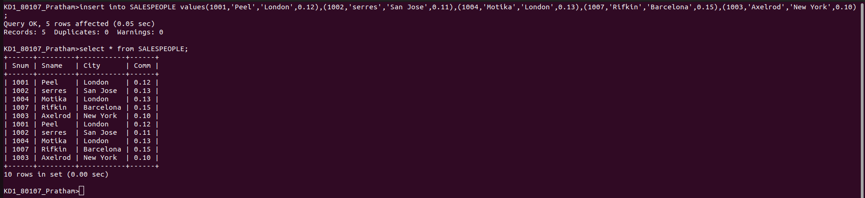

B) CUSTOMERS
Cnum int(4)
Cname varchar(10)
City varchar(10)
Rating int(4)
Snum int(4)


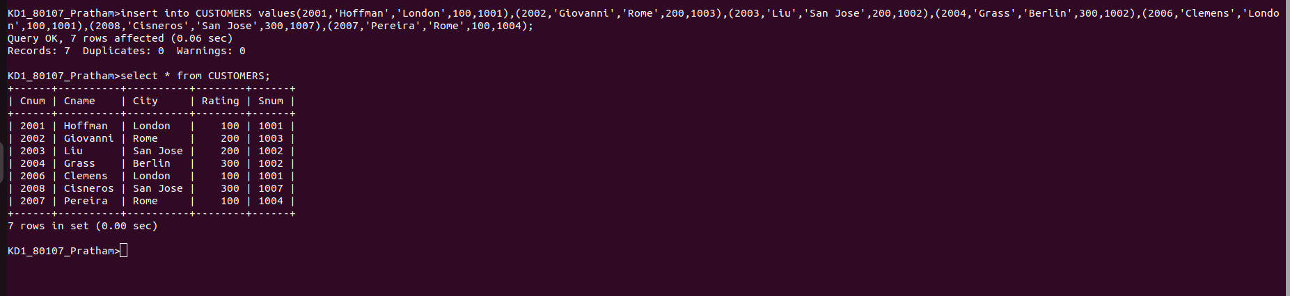

C) ORDERS :
Onum int(4)
Amt float(7,2)
Odate date
Cnum int(4)
Snum int(4)



